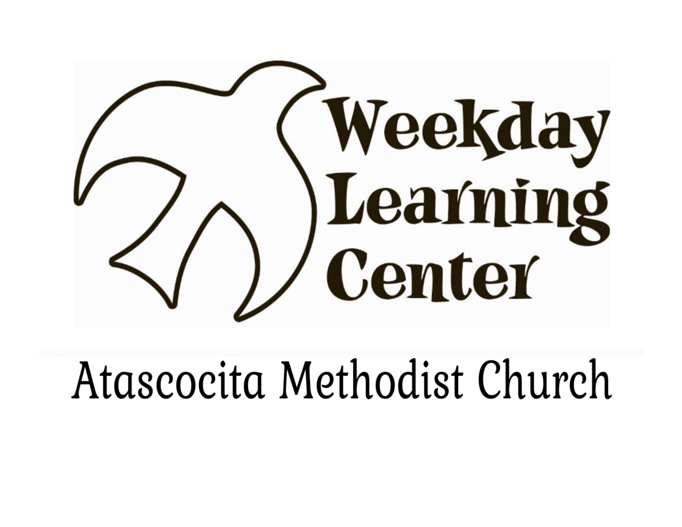

19325 Pinehurst Trail Drive

Humble, Texas 77346

281-852-0967

*"Be on your guard; stand firm in the faith; be courageous; be strong. Do everything in love."*

**1 Corinthians 16:13-14**

**W**eekday **L**earning **C**enter= **W**isdom, **L**ove, and **C**ourage

There is no place like home and there is no place like the Weekday Learning Center at Atascocita Methodist Church! The WLC will be celebrating 35 years of filling children with God’s wisdom and knowledge; 35 years of pouring God’s love into their hearts; and 35 years of drawing upon God’s courage and strength to carry us through. We have traveled down the “yellow brick road” of one adventure after another with God directing the way and we are excited for all that awaits us this year!

Registration for the 2025-26 school year and our Summer Fun program begins on January 17th for all current enrollees and AMC members. This year a new option for Registration has been added that allows the opportunity to split Registration into 3 equal payments beginning January 17th and ending on March 17, 2025. Registration paperwork MUST be turned into the WLC office by the January 17th deadline. After January 17th, the monthly payment will not be offered and for those choosing not to make installment payments, Registration will begin on February 17th.

The regular school year, that begins in August and ends in May, is for children 12 months by September 1st of the current school year to Pre K5 Bridge and Kindergarten. Our school year curriculum includes academics, along with daily activities of Chapel, Movin’ & Groovin’ gross motor skills class, playground, and Library. The PK5 Bridge Class and Kindergarten also attend a weekly music class with Dr. E, the Director of Music Arts, at Atascocita Methodist Church.

Our Summer Fun program, “Travels of the WLC”, is for children 12 months by September 1 of the current school year, through children entering the 4th grade. The program runs for 6 weeks on Tuesdays, Wednesdays, and Thursdays during the months of June and July. Summer Fun provides fun educational learning opportunities, including most of the great activities the regular school year has, such as Chapel and Movin’ & Groovin’. Travels of the WLC Summer Fun, will take the children on a road trip journey to exciting places God has made in the world.

At the Weekday Learning Center, God sends children off each day to follow the “yellow brick road” as they learn and experience all the wonderful things He does! Children go somewhere over the rainbow opening their minds to creativity and imagination through play directed activities. Daily adventures of age-appropriate curriculum focus on the whole child’s learning needs including academics, fine and gross motor skills, social interactions, and loving relationships with other children. The WLC classrooms are full of manipulatives, toys, books, and more. Our Kindergarten class also enjoys an interactive smartboard as an added curriculum tool. The Staff of the Weekday Learning Center are constantly striving to learn new strategies for classroom management, gathering learning tools, and creating exciting and engaging lesson plans. The WLC Staff also share in a daily morning devotion and prayer time constantly asking for God’s wisdom and guidance.

Our happy play days are recorded for regular viewing through Facebook uploads and daily parent feeds through Brightwheel (www.mybrightwheel.com), our online parent communication source. Candid shots and short videos chronicling each class, bring the classroom activities to life for parents, friends, and extended family on the Atascocita Methodist Weekday Learning Center Facebook page.

Registration packets are available online at [www.am-church.org](http://www.am-church.org). Click on the “Grow” tab, then on the Weekday Learning Center, and then on Registration Packet. Print the packet, complete, and return the paperwork, along with updated immunization/medical records, and birth certificates to the WLC office, following the Registration procedures below. Included in the packet, you will find all paperwork necessary to enroll your child in the Weekday Learning Center, as well as additional information about our program. Enrollment requirements include tuition payments drafted automatically each month using a credit card or ACH; birth certificate; immunization records (required complete at registration for everyone); physician’s well child statement (required complete at registration for everyone); and registration fees. The Weekday Learning Center accepts most forms of payment including Visa, MasterCard, Discover and American Express.

All available spaces are filled on a first come, first served basis. Waiting lists will begin as soon as a class has filled with paid registration forms. Registration procedures for key dates are below:

1. **Current Enrollees, Siblings, and AMC members- Installment Plan:** Registration begins on December 17th and ends on January 17th. Paperwork should be turned in to WLC Director, Beth Johnson or Assistant Director, Darla Janak, in car lines during the morning and afternoon or may be dropped off at the WLC Office. Registration total will be divided into 3 payments that will be drafted on January 17th, February 17th, and March 17th.
2. **Current Enrollees, Siblings and AMC members – not choosing installment plan:** Registration begins on February 17th . Paperwork should be turned in to WLC Director, Beth Johnson or Assistant Director, Darla Janak, in car lines during the morning and afternoon or may be dropped off at the WLC Office. Please do not send Registration packets in your child’s backpack.
3. **Open Enrollment** will begin on Monday, February 24th. Doors will open at approximately 7am at the front doors of the Life Center (metal building next to vacant lot, and doors facing Pinehurst Trail Drive). Registration payment is due upon receipt of paperwork, and all paperwork must be complete.

Quoting some favorite characters from the Wizard of Oz that emulate what we strive to help children know and feel:

**W**isdom- brains do not make one happy and happiness is the best thing in the world. (Scarecrow)

**L**ove- A heart is not judged by how much you love, but how much you are loved. (Tin Man)

**C**ourage- True courage is in facing danger when you are afraid. (Cowardly Lion)

Children really are home here at the Weekday L earning Center where God’s wisdom, love, and courage cover and carry children somewhere over the rainbow to places where dreams that you dare to dream really do come true. And yes, at the WLC, you are always home! (Dorothy)

Blessings,

Beth Johnson

Atascocita Methodist Church Weekday Learning Center Director

[beth@am-church.org](mailto:beth@am-church.org)